**Smart Sensor Fusion for Occupancy Detection and Human Counting**

22nd – 23rd March, 2014

Hackathon-2014

Designed by:

Piyush Manavar

Sanam Shakiya

Saurav Shandilya

Vishwanathan Iyer

**Idea**:

Our sensing system uses integration of interruption counter, Passive Infrared (PIR) motion sensors and camera to detect count, occupancy, authenticate user and switch lights in specific region on room. Data regarding entry, exit, occupancy/non-occupancy in region is received and stored in database along with time stamp for future analysis.

Interruption counter gives count of person entering and/or leaving a room. It comprises of LASER as light source and LDR as detector. Whenever a person enter/exit from a room, count is recorded in the system and triggers camera to capture human face and run face recognition algorithm.

Motion sensors detect moving objects emitting infrared (IR) radiation. Human body is source of Infrared radiation and hence can detect motion of people. Major problem encountered with motion sensors are that they can only detect motion of object i.e. when a person is not still, motion sensors cannot detect it. We planned to overcome this problem by moving the PIR motion sensor to scan the area. Motion of sensor cause relative motion between a person and sensor, thus detecting even a still person. Motion sensors are mounted in two different regions in a room covering entire room. Based on region in which person is detected, Fan is switched on respective region.

Camera is used for detecting human entering a room. A face recognition algorithm is able to detect and recognise human registered in the system. Camera is triggered as soon as person is detected by interruption counter. Person recognition turn on the light allocated for that specific person

Data is received from interruption counter to count number of people entry and exit. Motion sensor data predict the location of room which is occupied. Data is stored in database.

**Block Diagram:**

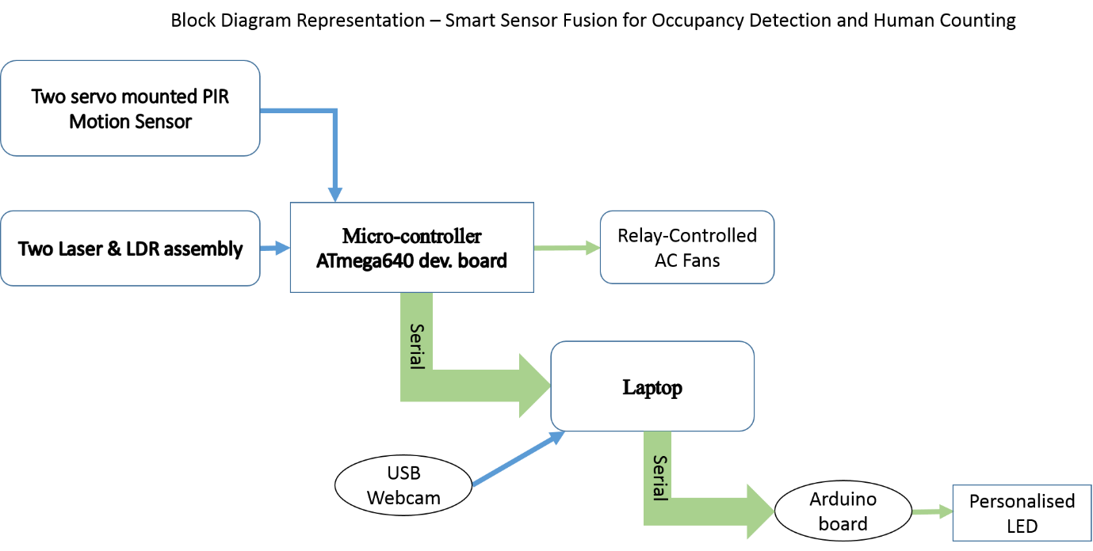

Figure-1: Block Diagram

**System Description:**

System comprises of LDR, PIR motion sensor and servo motor interfaced with ATmega640 development board. Laser-LDR is used as interruption counter to detect human entry and exit. Laser works as light source and is received by LDR. Whenever a human entry/exit, it cuts the laser path, varying the resistance of LDR. Consequently varying the voltage. Accuracy of counting system is 100%. It fails in cases where two people enters exactly together or when person enter running. First problem can be easily eliminated by making a frame allowing only single person to enter/exit.

PIR is mounted on servo motor and is rotated in every 20 seconds to scan the area. It is able to detect people sitting still in every cases.

Relay is used to control the fans.

Face detection and recognition is done in matlab. For recognition images of face of size 100*100 size is required. So before recognition detection is required. In which face is detected from captured image and recognized from images in database.

For detection, in matlab ‘vision.CascadeObjectDetector’ whose documentation is found in [2]

For recognition we used the face recognition algorithm code implemented by Philipp Wagner[3], whose documentation describes the procedures in matlab. We used the Eigen Face method for recognition.

So in matlab procedure followed were:

1. Creating the image database which consist 10 images per subject.
2. Then feature extraction is done for the images in database along with the id for each subject.
3. When query image (cropped face) is passed through the face recognition using prediction function which gives the id of recognized subject.

Functions from matlab code repository[4]

read_images(folder)- Read images from a given path and return the Imagematrix

eigenfaces(X,y,10)- Performs a Principal Component Analysis on X and stores num_components principal components.

eigenfaces_predict(model, Xtest, 1)- Predicts nearest neighbor for given Eigenfaces model which gives the id for the recognized subject

In current system, for known subject from database 5 burst image from single subjected were tested. Total Person in database is 6. Detection of human is done with 100% accuracy, however recognition percentage is less and vary depending on various scenario.

**Hardware Used:**

1. ATmega640 development Board[1]
2. Light dependent Resistor (LDR)
3. LASER
4. PIR Motion Sensor
5. Servo Motor
6. Camera
7. Relay
8. Fans
9. LEDs

**Function State Chart:**

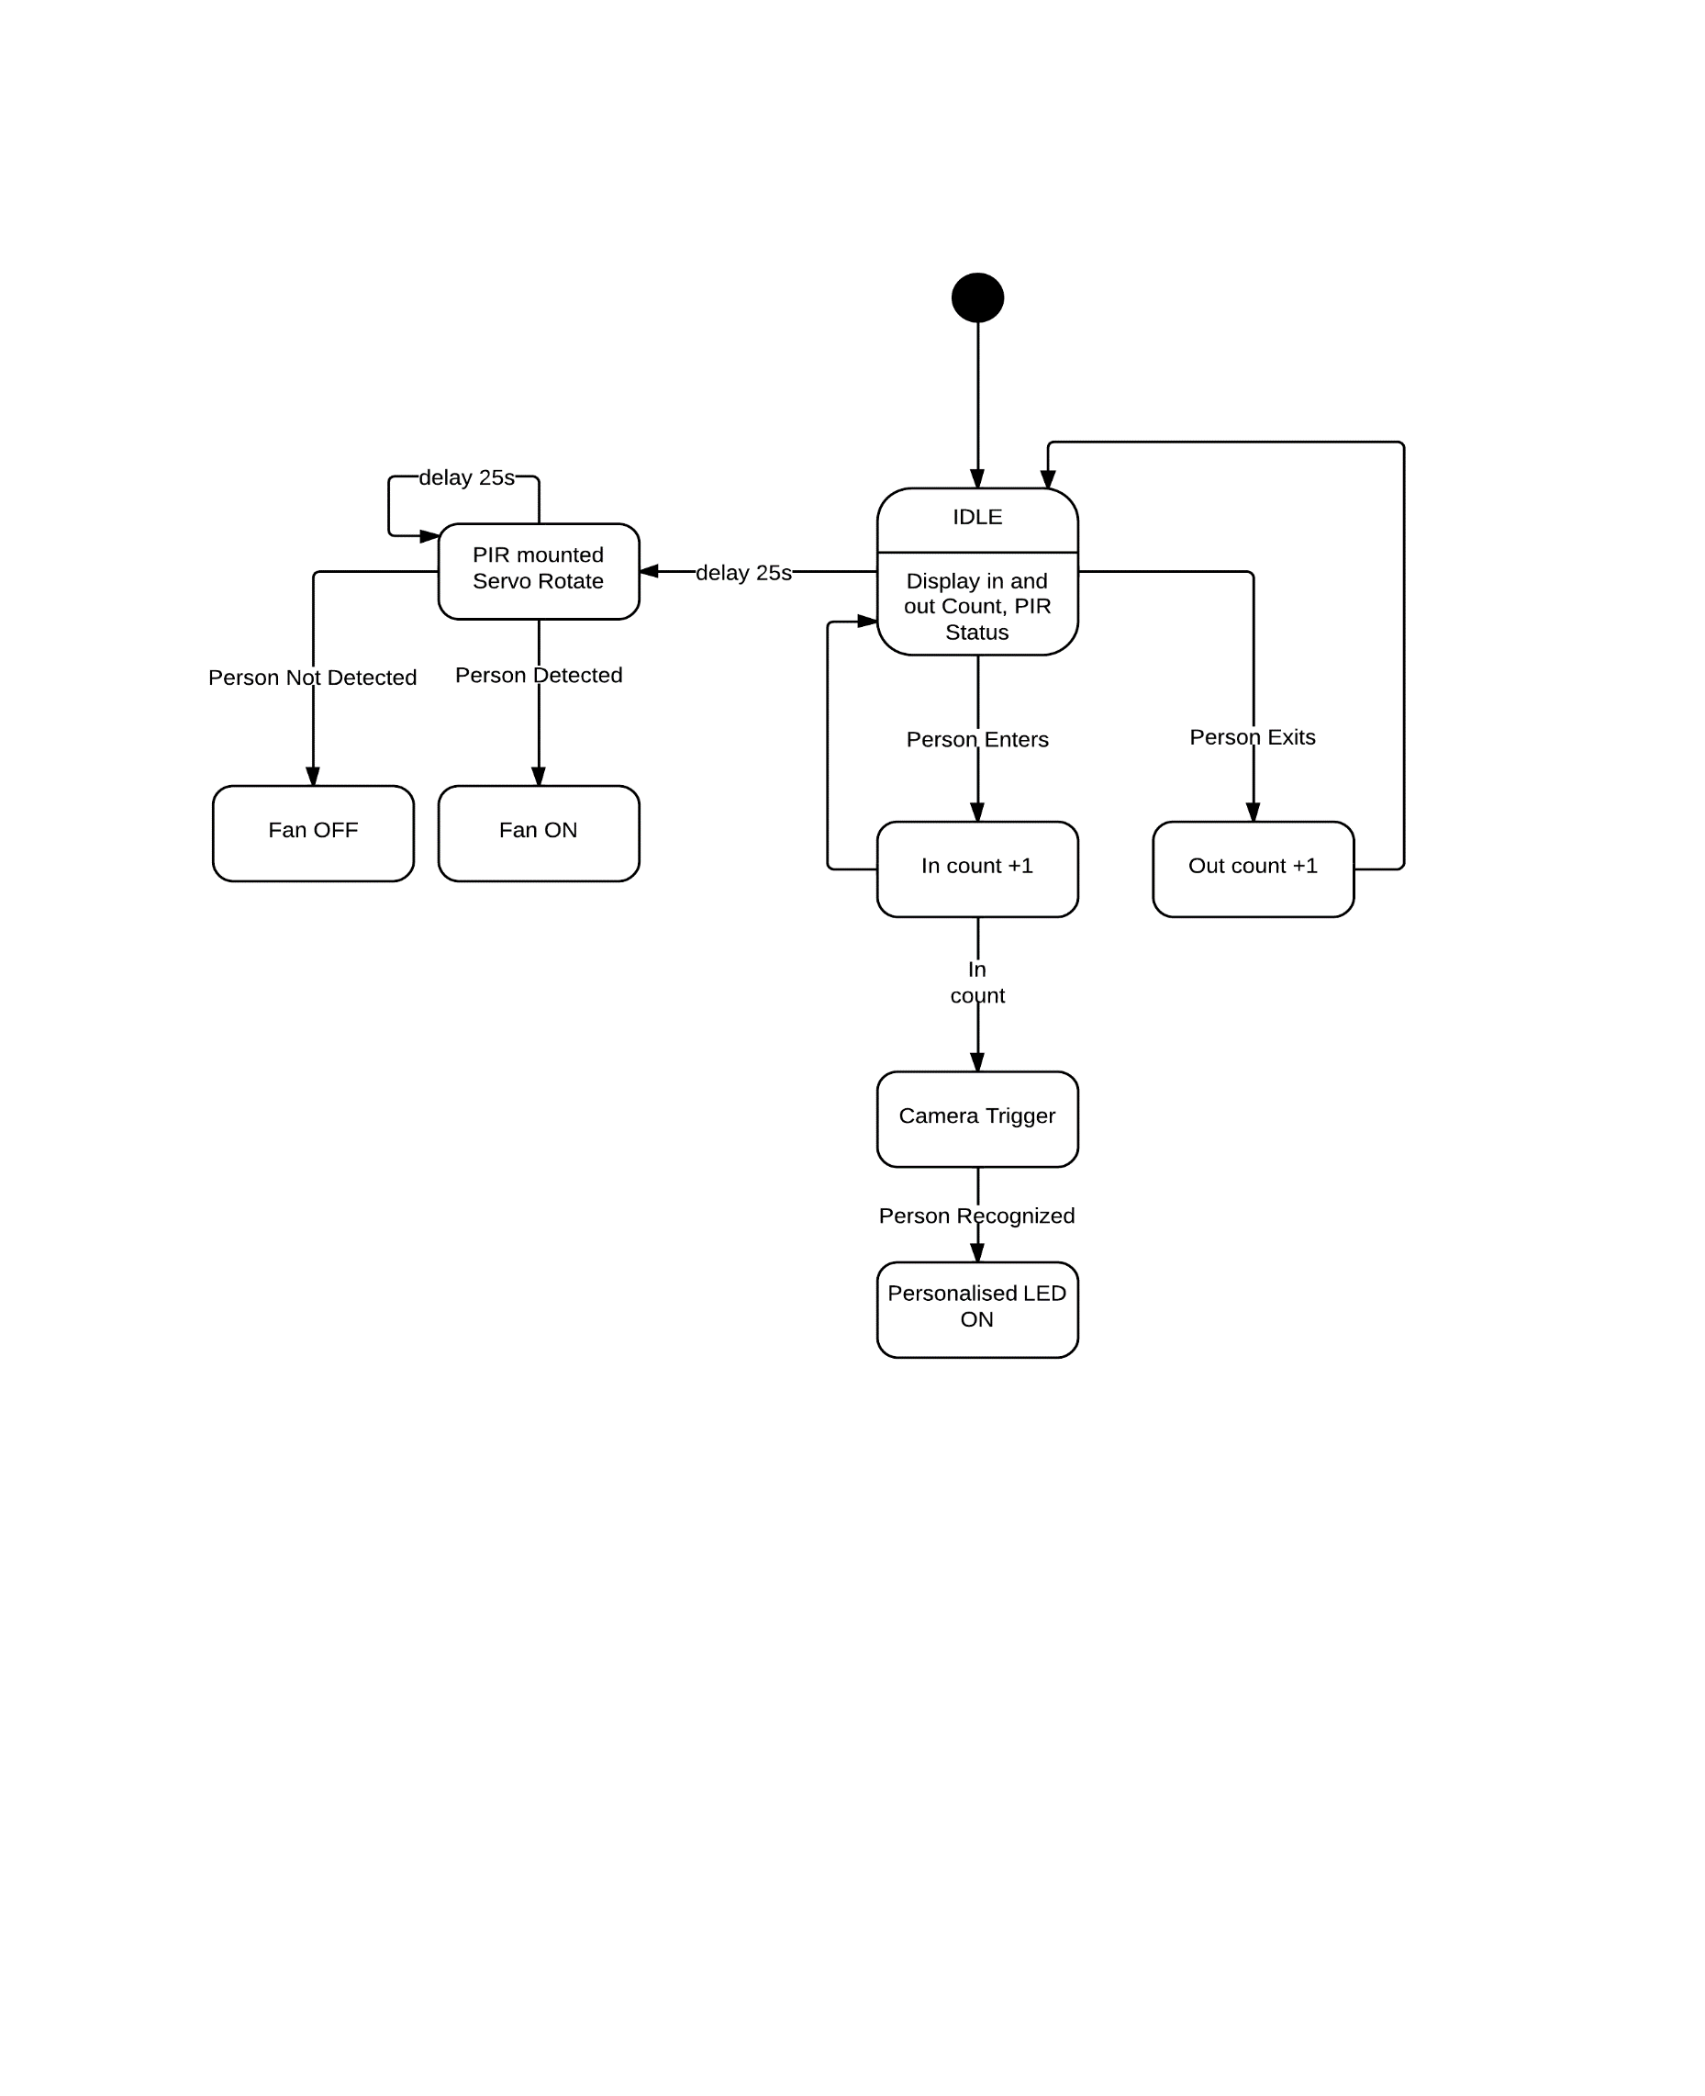

**Circuit Diagrams:**

Circuit diagram shown in figure below is signal conditioning circuit for LDR. It comprises of an opamp LM324 (configured in comparator mode) which converts LDR analog voltage into digital level voltage. This is fed to digital pin of microcontroller.

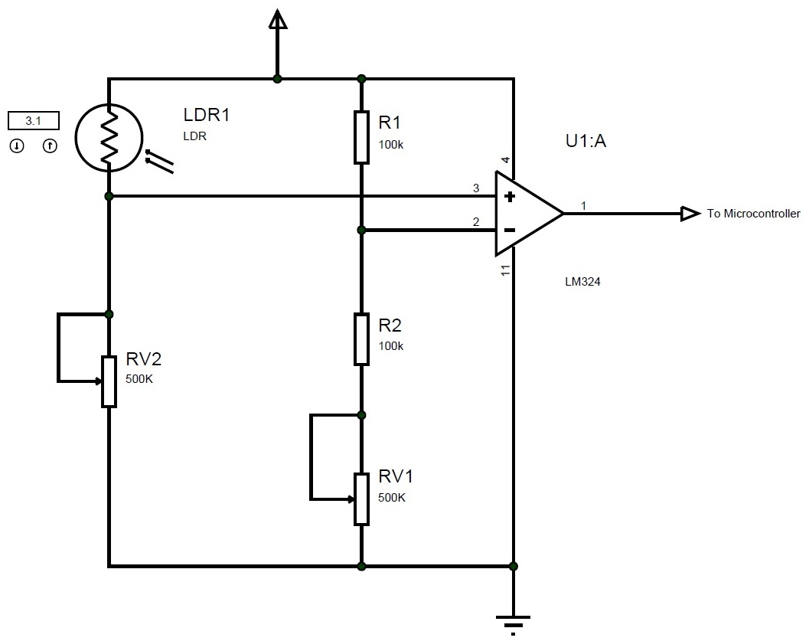

**Scalability and Future Enhancements:**

1. Array of Lasers and LDRs can be designed to increase sensing capability of interruption counter.
2. System can be scaled up to control room’s tube-light, fan, AC and other appliance. Necessary modification may require permission from department.
3. Enhancement in face recognition algorithm with moving people.
4. System can be integrate with more sensor with existing system without adding microcontroller board.
5. Can be sense particular area and control only that much area for energy saving.
6. Whenever a person enters a room, he/she can be recognised and by using machine learning algorithm specific user profile can be upload for example set on their PC, lights near their area.
7. By using time triggered RTOS, accuracy of counter can be increase.

**References**:

1. Nex-Robotics manufactured development board. Manual provide in folder.
2. <http://www.mathworks.in/help/vision/ref/vision.cascadeobjectdetectorclass.html>
3. <http://www.bytefish.de/pdf/facerec_octave.pdf>
4. <https://github.com/bytefish/facerec>